**CONFERENCE MANAGEMENT SYSTEM MANUAL**

**Registration (All Users)**

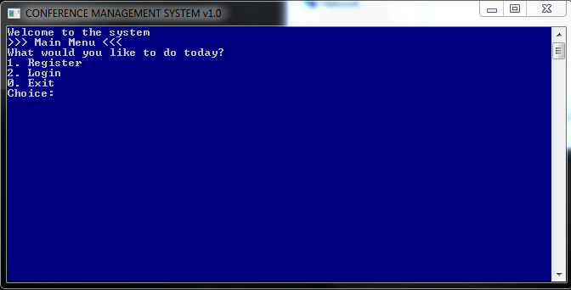

* Enter option 1 for Registeration

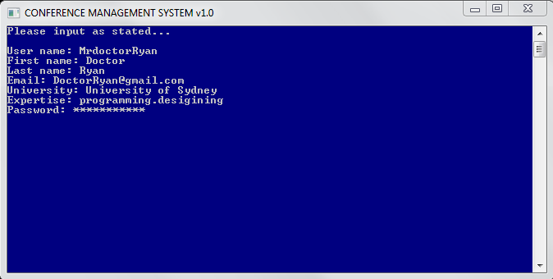

* Enter your personal information for registration. ( If you have multiple expertises, please seperate them with a “ . “, as shown in the example above)

**Login (All Users)**



* Enter Option 2 for login

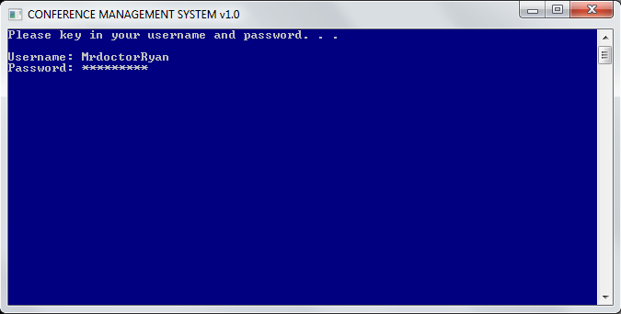

* Enter your Username and Password

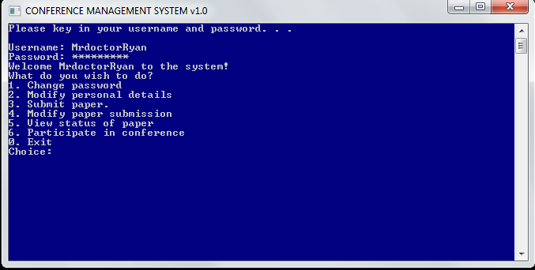

* Successfully logging in will show you the main page.

**Changing Password (All Users)**



* Login with your username and password to the home page.
* Enter Option 1 in main page to change password.

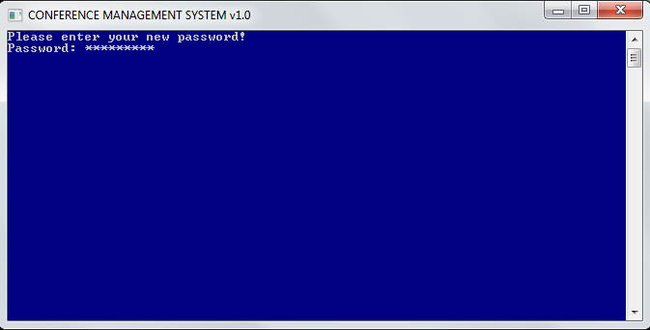

* Enter your new password.Upon completetion, user will be brought back to main menu.

**Modify personal details (All Users)**

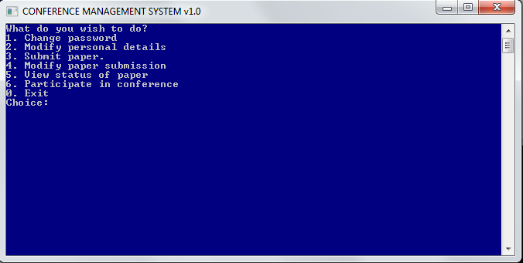

* Login with your username and password to home page
* Enter Option 2 in main page to modify personl details

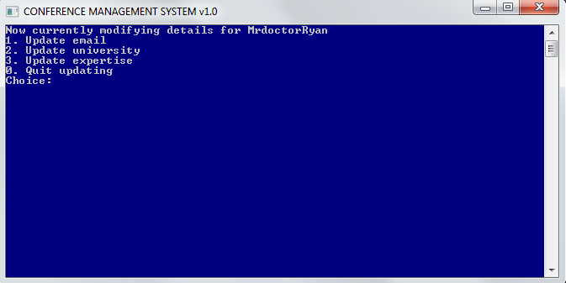

* Enter option which you want to update or enter Option 0 to quit to main menu.

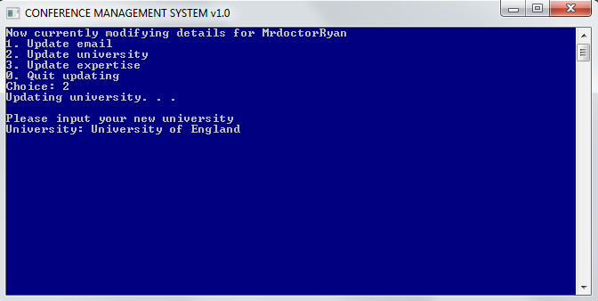

* User enters the new details on what he/she intends to change. (In the example above, the university of the user is changed.

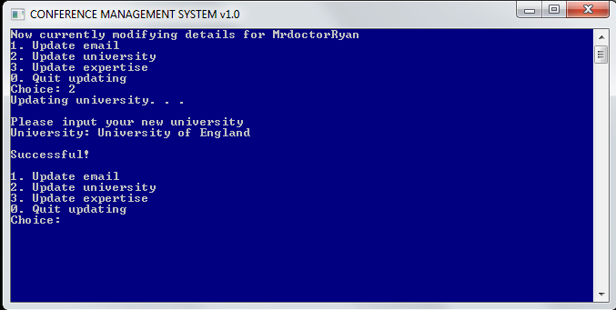

* Upon successful change, the user will be prompt if want to edit more personal details. If not, user enters 0 to go back to main menu.

**Submit paper (All Users)**

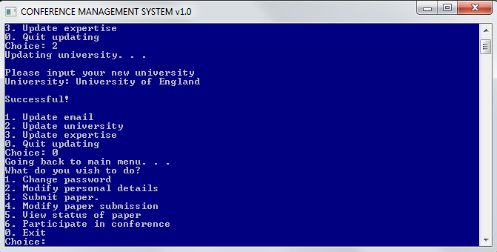

* Login with your username and password to home page
* Enter Option 3 in main page to submit paper

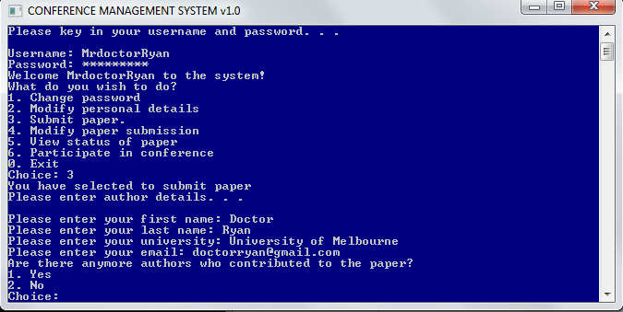

* User enters author details in the above example.

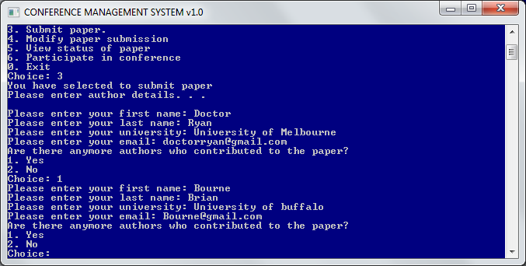

* User selects option 2 if he/she wishes to add in more then one author.
* User enters additional author information as in the above example.

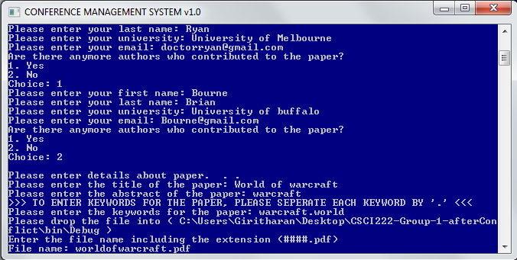

* User enters title, abstract and keywords for the paper. ( If you have multiple keywords, please seperate them with a “ . “, as shown in the example above)
* For paper submission, place the paper into the directory specified. As shown above.
* Upon succesful submission, the user will be prompt back to the main menu

**Modify paper submission (All Users)**

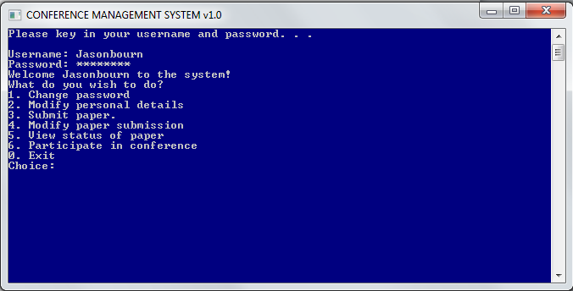

* User enters Option 4 to modify paper submission

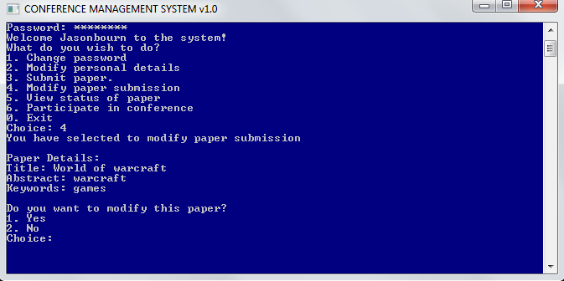

* User enters Option 1 to modify the paper or Option 2 to skip to next paper. If there are no more papers, the system will return back to main menu.

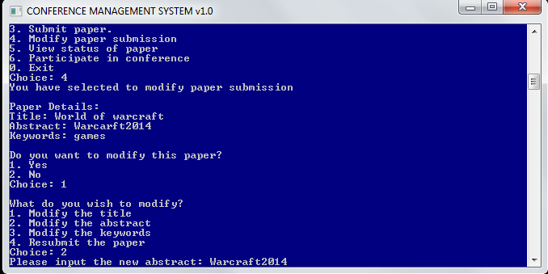

* User enters the new details on what he/she intends to change. (In the example above, the abstract of the paper is changed.
* Upon completion user will be brought back to main menu.

**View status of paper (All Users)**

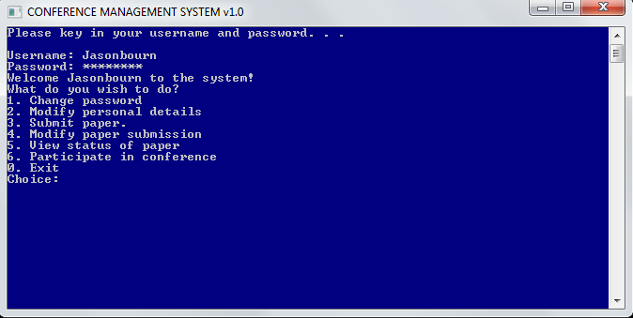

* User enters option 5 to view status of the paper.

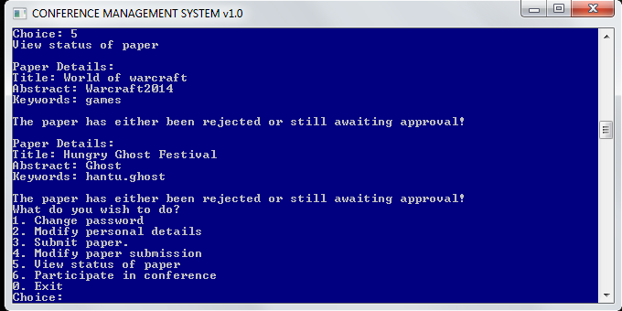

* System will display the status of all the papers that the user contributed. Once done, it will return back to main menu.

**Participate in conference (All Users)**

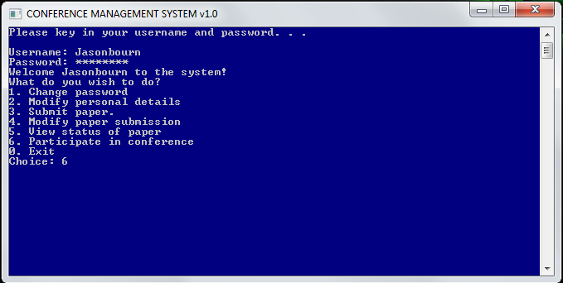

* User enter Option 6 to participate in conference

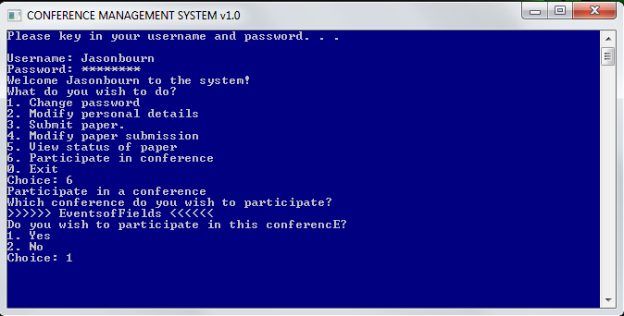

* User chooses option 1 to partcipate in the conference or 2 to skip to next conference avaliable. If there are no conferences avaliable, the system will return back to main menu.

**Specify preference (Program Committee)**

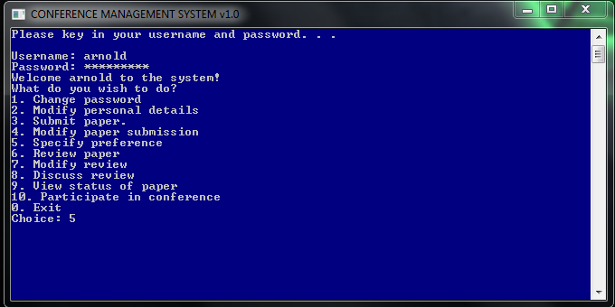

* User enters option 5 to Specify preference for paper

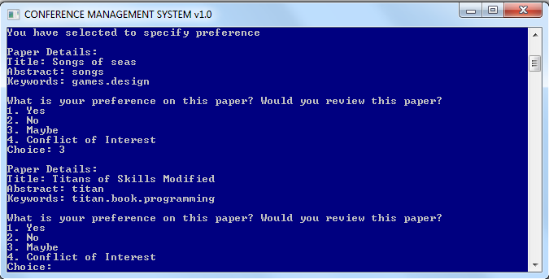

* User select the preference for the paper. If there are more papers assigned to the user, this process will repeat.

**Review paper (Program Committee)**

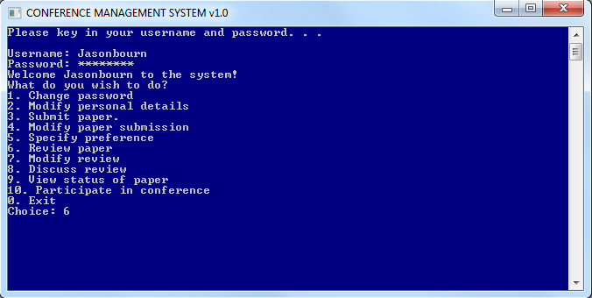

* User select Option 6 to Review paper

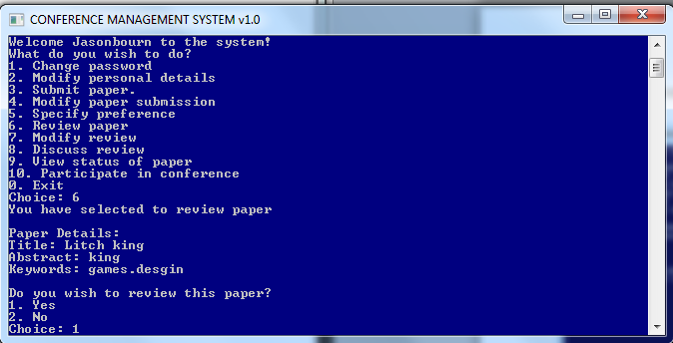

* User select Option 1 if he choose to review the following paper or 2 to skip reviewing this paper. If there is no other papers to be reviewed, the system will return back to main menu. Upon choosing to review the paper, the paper the user review, will be sent back to the user’s directory (Can be seen on next image).

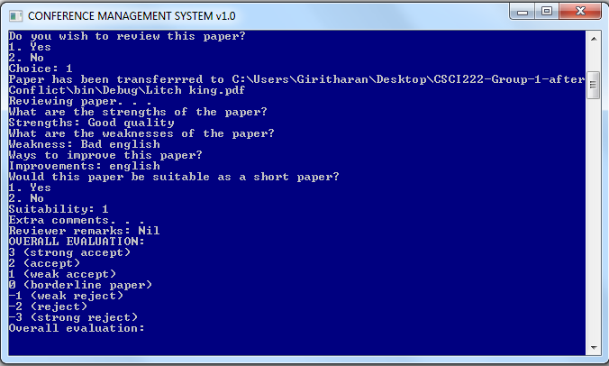

* User inputs the information for reviewing the paper. The process is repeated until all assigned paper has been reviewed. Upon completion, the system will return back to main menu.

**Modify review (Program Committee)**

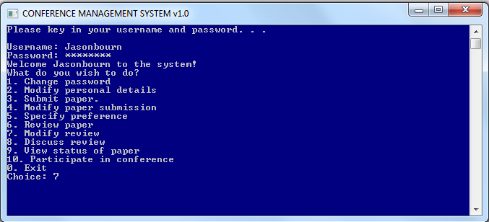

* User select option 7 to Modify review the papers he have reviewed earlier.

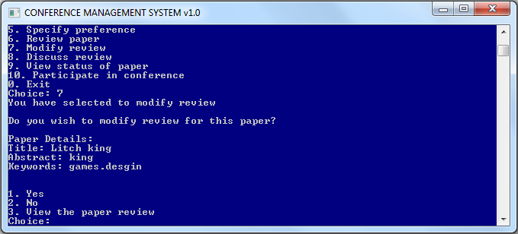

* User select option 1 if he/she chooses to modify the review

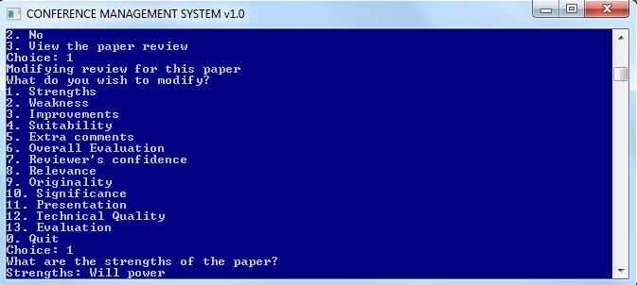

* User makes the decision on what to modify depending on what he/she intends to modify. (In the example above, the Strength for the paper is been modified). The user chooses 0 to quit

**Discuss review (Program Committee)**

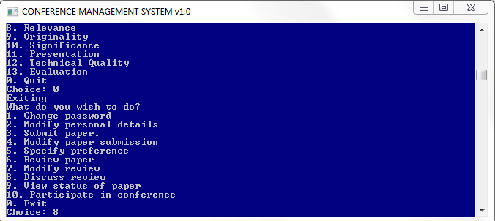

* User select option 8 to discuss review.

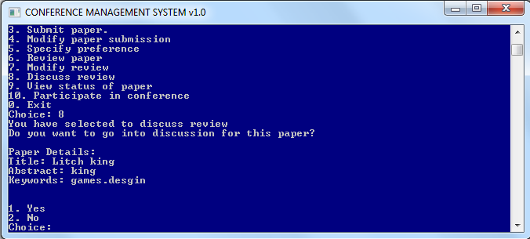

* User selects option 1 to participate in the discussion for the paper.

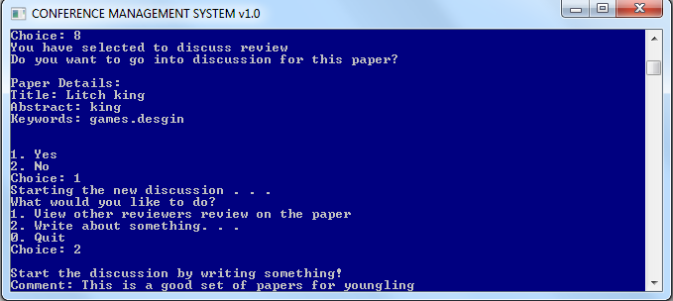

* User selects Option 2 to write a comment or option 1 to view other reviewers review on the paper. If there is an existing discussion on the paper, the user is able to view discussions already done.
* User selects Option 0 to return back to main menu.

**Assign Program Committee (Program Committee Chair)**

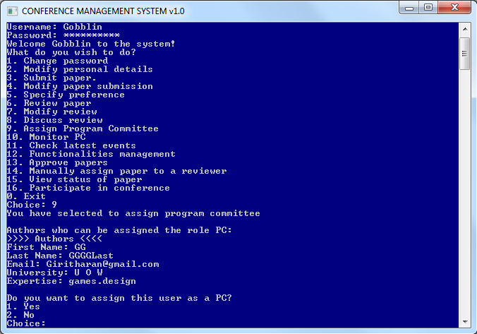

* User select option 9 to upgrade user to Program committee. The system will display all the users which are able to be assigned the role of program committee. User can choose option 1 to assign or option 2 to not assign.

**Monitor PC (Program Committee Chair)**

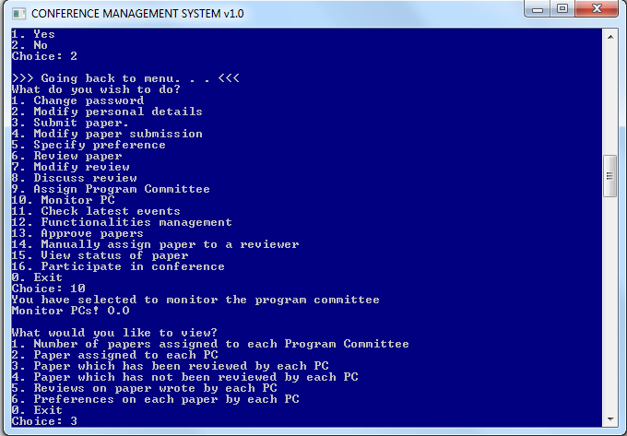

* User select option 10 to Monitor PC
* User can choose different options to monitor PCs on.
  + Option 1 to view number of papers assigned to each PC
  + Option 2 to view the paper assigned to each PC
  + Option 3 to view paper which has been reviewed by each PC
  + Option 4 to view paper which has not been reviewed by each PC
  + Option 5 to view reviews on paper wrote by each PC
  + Option 6 to view preferences on each paper by each PC

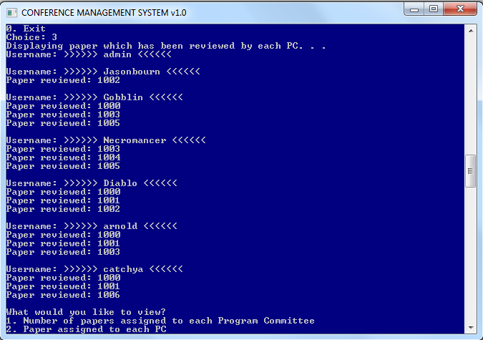

* Upon selecting Option 3, the system displays the paper which have been reviewed by different Program Committee (PC)
* The user can continue to view other options or can select Option 0 to return back to main menu

**Check latest events (Program Committee Chair)**

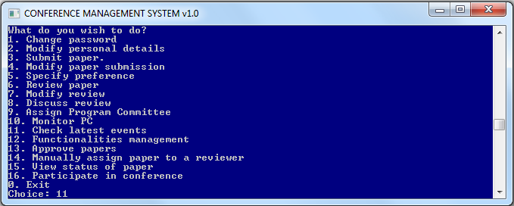

* User select Option 11 to check latest events

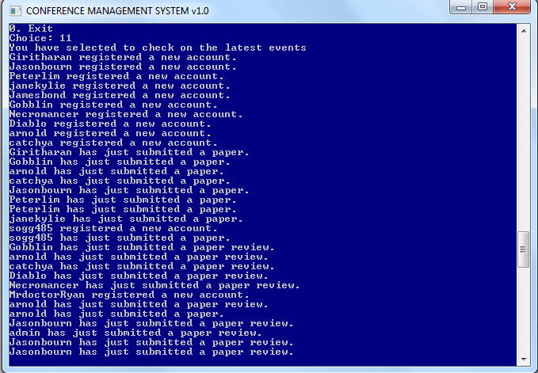

* The system displays the events which takes place in the system (For Example new users registered into account, Users submitted paper. )

**Manage Functionalities (Program Committee Chair)**

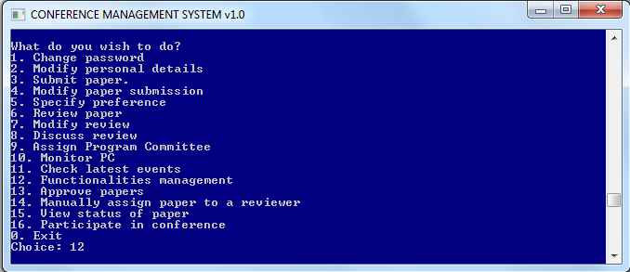

* User selects Option 12 to manage the Functionalities of the system

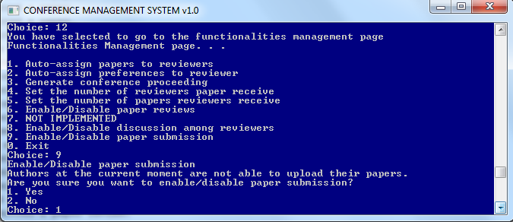

* User selects Option ‘1’ if chooses to auto-assign the papers to reviewers
* User selects Option ‘2’ if chooses to auto-assign preferences to reviewer
* User selects Option ‘3’ if chooses to generate the conference proceeding
* User selects Option ‘4’ if chooses to set the number of reviewers paper receieved
* User selects Option ‘5’ if he/she chooses to set the number of papers reviewers receieved
* User selects Option ‘6’ to enable or disable paper reviews
* User selects Option ‘8’ to enable or disable discussion amon reviewers
* User selects Option ‘9’ to enable or disable paper submission
* Upon selection of the options above the system will prompt a confirmation which is yes or no to the user. ( Shown in the above example )
* User selects Option ‘0’ to exit and return back to main menu.

**Approve papers (Program Committee Chair)**

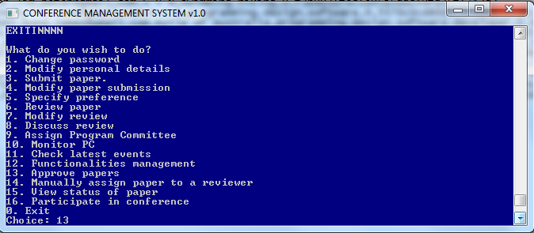

* User selects Option 13 to approve papers.

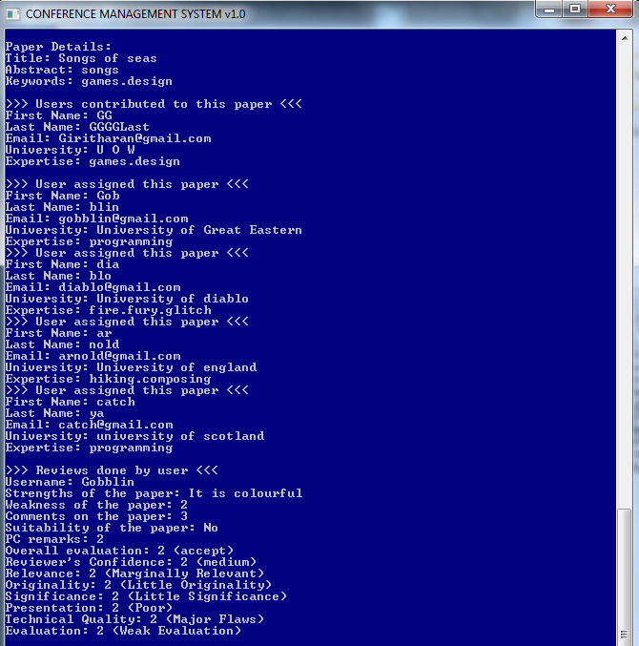

* Upon user selecting Option 13 which is for Approve papers, the system will display
* The Paper details
* The Users contributed to the paper
* The User assigned to the paper
* The Users who done the review for the paper.

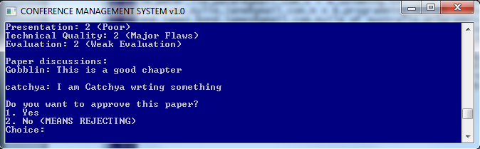

* Next the system will prompt the user for approval of the paper. Option 1 for yes or Option 2 for no.
* After option is been selected, the system will display for the next paper with the same process above.

**Manually assign paper to a reviewer (Program Committee Chair)**

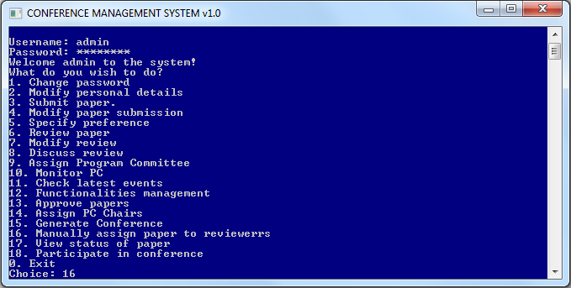

* User select Option 16 to manually assign paper to reviewers

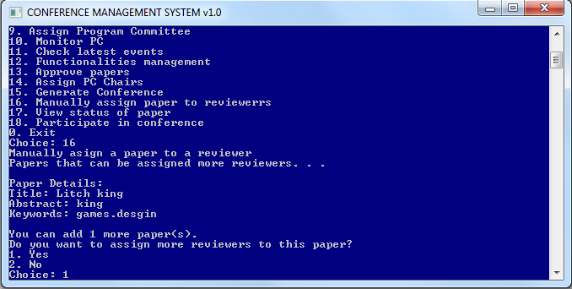

* System will display the amount reviewers which can be assigned to the paper.
* User selects Option 1 to add a reviewer to the paper.
* Next the system will continue the process above and prompt the user whether he/she choose to assign reviewers

**Generate Conference (Administrator)**

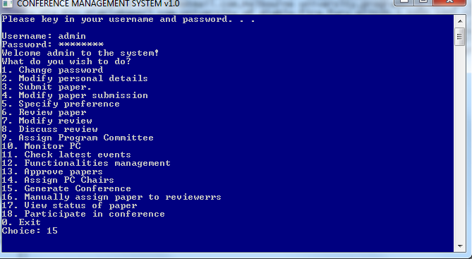

* User selects Option 15 to generate a new conference.

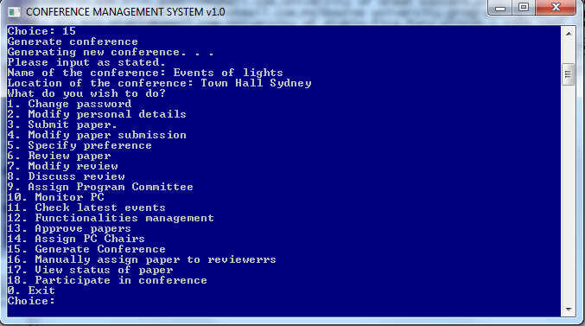

* Upon selecting Option 15, the system will prompt the user to enter details about the conference for example: Name of the conference and Location of the conference.
* Next the system will return back to the main menu upon generating conference successfully.

**Assign PC Chairs (Administrator)**

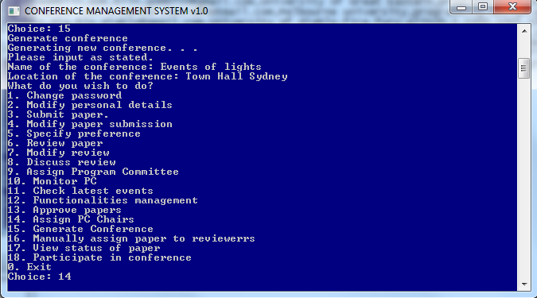

* User selects Option 14 to assign PC Chairs.

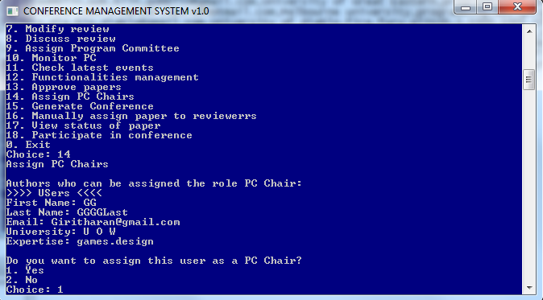

* The system will display all the users which are able to be upgraded to program committee Chair. User can choose option 1 to assign or option 2 to not assign. Upon completion, the system will return back to main menu.